Data Sheet
Product Information
Product Name | : | Recombinant Human Thioredoxin1 (rhTRX1)
Synonyms | : | TXN, TRDX, TRX, TRX1, thioredoxin
Description | : | Thioredoxins are proteins that act as antioxidants by facilitating the reduction of other proteins by cysteine thiol-disulfide exchange. Thioredoxins are found in nearly all known organisms and are essential for life in mammals. Thioredoxin is a 12-kD oxidoreductase enzyme containing a dithiol-disulfide active site. It is ubiquitous and found in many organisms from plants and bacteria to mammals. Two cysteines, CXXC motif, are the key to the ability of thioredoxin to reduce other proteins. Thioredoxin proteins also have a characteristic tertiary structure termed the thioredoxin fold. (Ref. From Wikipedia)
NCBI Accession No. | : | NM_003329.3
Amino acid sequence | : | MVKQIESKTAFQEALDAAGDKLVVVDFSATWCGPCKMIKPFFHSLSEKYSNVIFLEVDVDDCQDVASECEVKCMPTFQFFKKGQKVGEFSGANKEKLEATINELV*
Molecular Mass | : | 11.71 kDa (105 aa)
Protein Tags | : | No tagging
Source | : | E. coli.
Cat. No. | : | JW-H039-0500, JW-H039-1000
Storage | : | Should be at ≤ -70 ℃ as undiluted aliquots of handy size. Avoid repeated freezing and thawing.
Cross Reactivity | : | Human, Mouse, Pig, Rabbit, Rat, Sheep, Chicken

Quality Control
Test items |  | Specifications
Appearance | : | Clear, colorless liquid
Purity | : | Greater than 95 % by SDS-PAGE
Specificity | : | Using Western blot, detection | 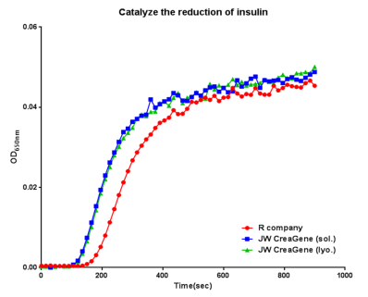
Concentration | : | 0.1 mg/㎖, Bradford method
Biological Activity | : | Measured by its ability to catalyze the reduction of insulin. The reaction leads to precipitation, which can be measured by absorbance at 650nm. The specific activity is >10 A650/min/mg
Endotoxin | : | Less than 0.5 EU/㎍ as determined by the LAL method
Formulation | : | PBS, 0.1mM DTT (pH7.4) without preservative or carrier proteins.
Stability | : | Stable for up to 12 months at -70 ℃. Stable for a month at 4 ℃.
Sterility | : | Sterilized through a 0.2 ㎛ membrane filter and packaged aseptically. Culture for 2 weeks, no growth

